The Mixed Nuts
ZZ Swing Set Last revised on 2015-10-22

SWING01-D01-Alright, Okay, You Win(K).2014.03.12.pdf
SWING02-AA17-Back Home Again In Indiana(KVF).2015.06.14.pdf
SWING02-AA17-Back Home Again In Indiana(KVM).2015.06.14.pdf
SWING03-S13-Dipsy Doodle(KVF).2015.05.10.pdf
SWING04-BB01-Don't Be That Way(K).2014.04.26.pdf
SWING05-Gospel17-Gotta Be This Or That(KVF).2014.04.19.pdf
SWING05-Gospel17-Gotta Be This Or That(KVM).2014.04.19.pdf
SWING06-E01-It Don't Mean A Thing(KVM).2015.10.22.pdf
SWING06-E01-It Don't Mean A Thing(KVF).2015.10.22.pdf
SWING07-Joshua Fit The Battle Of Jericho(K).pdf
SWING08-X17-King Porter Stomp(K).2014.08.20.pdf
SWING10-FF17-Muskrat Ramble(K).2015.09.20.pdf
SWING11-JJ01-This Could Be The Start Of Something Big(KVD).2015.04.24.pdf
SWING11-JJ01-This Could Be The Start Of Something Big(VOCAL DUET).2015.04.24.pdf
SWING12-Opus One(K).pdf
SWING13-KK09-Rag Mop(KVF).pdf
SWING13-KK09-Rag Mop(KVM).pdf
SWING14-DD17-Royal Garden Blues(K).2013.11.17.pdf
SWING15-P17-Shoo Fly Pie(KVF).2015.01.25.pdf
SWING15-P17-Shoo Fly Pie(KVM).2015.01.25.pdf
SWING16-L17-Stompin' At The Savoy(K).2015.01.18.pdf

SWING17-LL17-'Taint What You Do(KVF).pdf
SWING17-LL17-'Taint What You Do(KVM).pdf
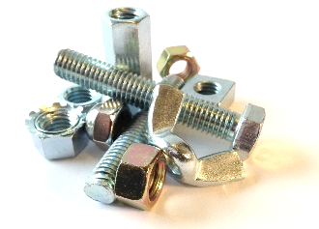
SWING18-K17-One O'Clock Jump(K).pdf

